HCI Project:

School Management System

Project Members:

Abdullah Tilal 19k-1103

Sadeem Sattar 19k-1102

Salman Ahmed Khan 19k-1043

Predictability: User can predict by viewing the login page and home screen that the user click on the button, certain actions will be formed. So, user can predict the behavior.

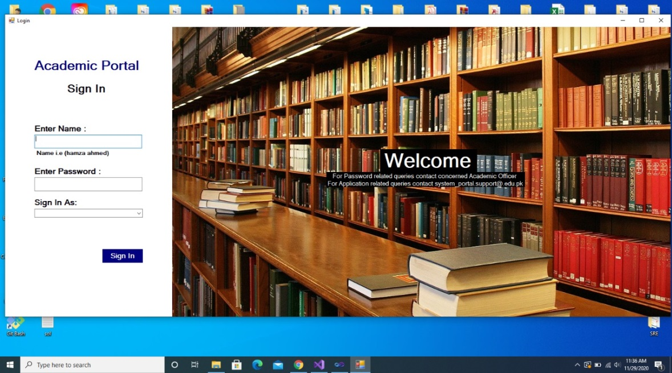

Operation Visibility: All the operations are visible with the concept of affordance and more is focus on recognition rather than recall. All the buttons and metaphor used are clearly visible for their operation.

Familiarity: The metaphors used in project are real-world images. Thus, this create the user familiar with the system.

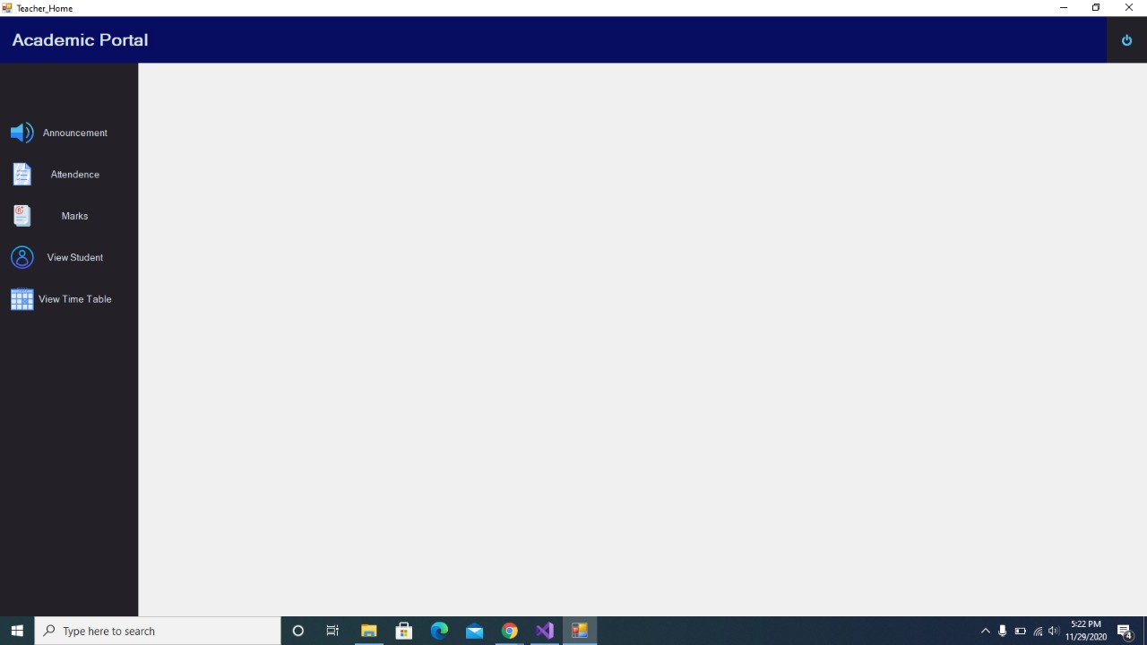

Generalizability: The system provides knowledge of the form fill similar to the paper based system. 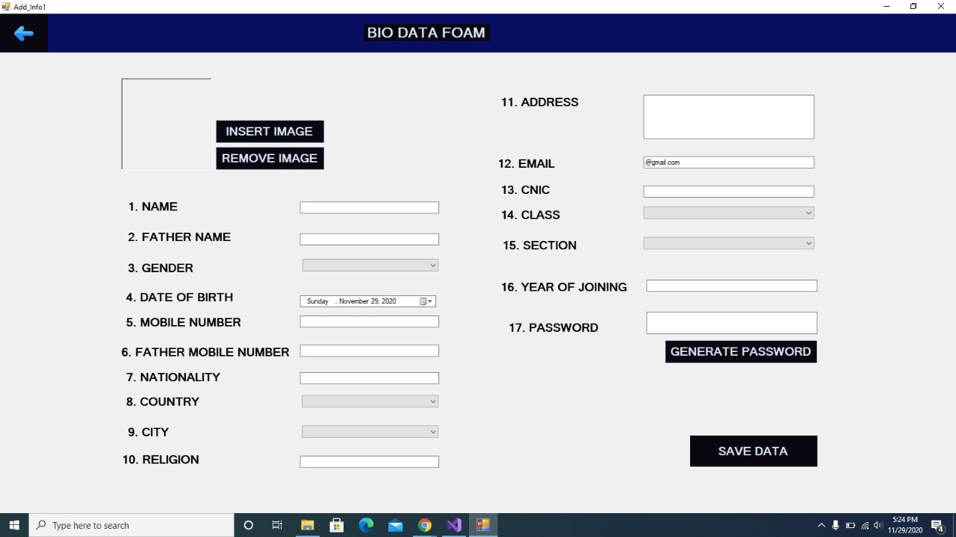

Consistency: All the color of buttons, text, Position of buttons, combo box, layout and appearance are consistent for all category of user (admin, teacher and student). 

Synthesizability: All the affect of user actions will be provided whether they are exceptions or the conformance of the goal in the form of message box.

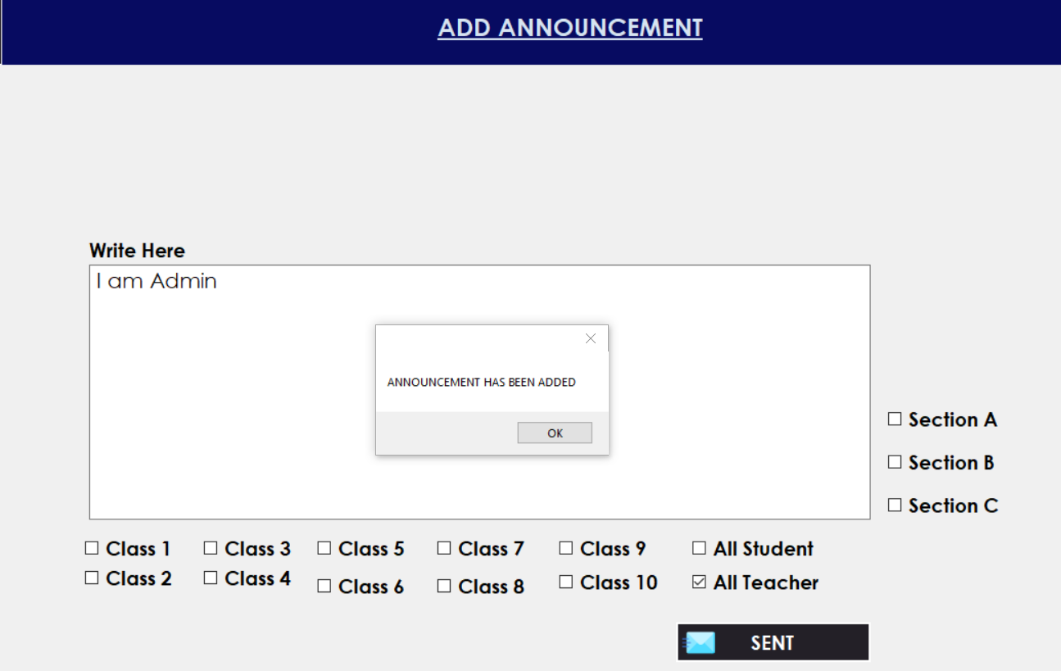

Immediate feedback

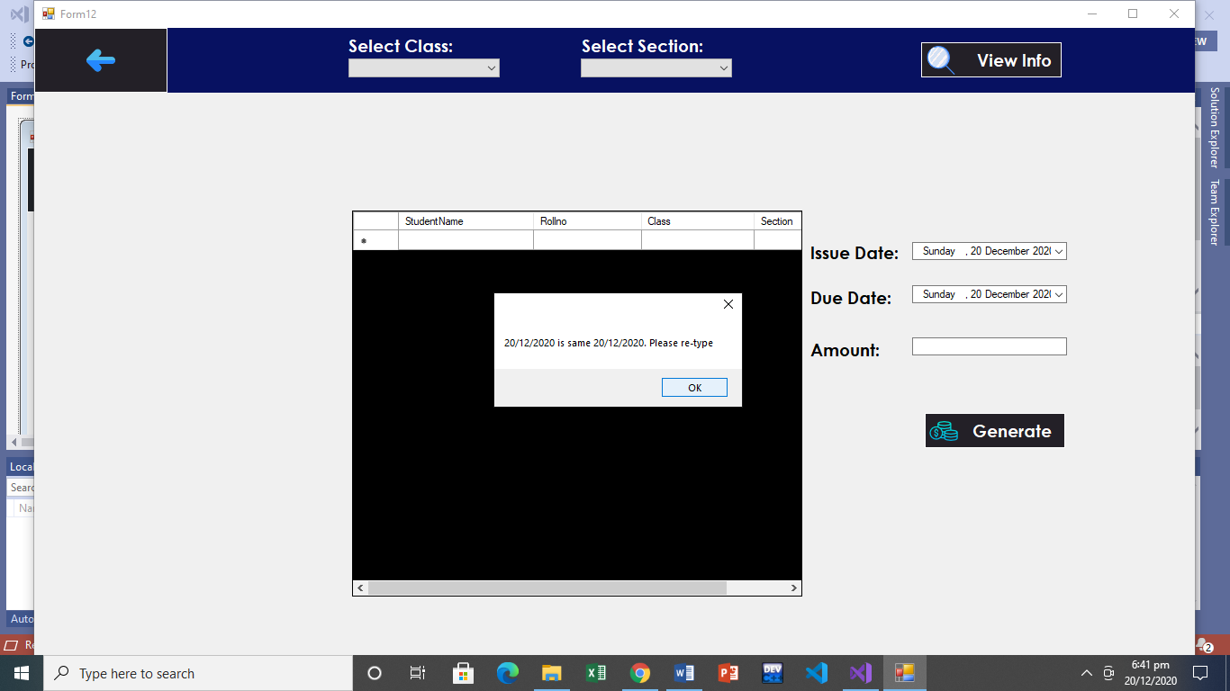Dialogue Initiative: The system will provide dialogue initiative when any field is missing or any input provide is incorrect. Also, user can do dialogue initiate by clicking on buttons in order to open the require page.

User Dialogue Initiative will come to select date

System Dialogue Initiative

Task Migration: The task of user (teacher) in attendance page is that the students will be marked present by default, so user will not have to do it manually. It just needs to mark leave or absent.

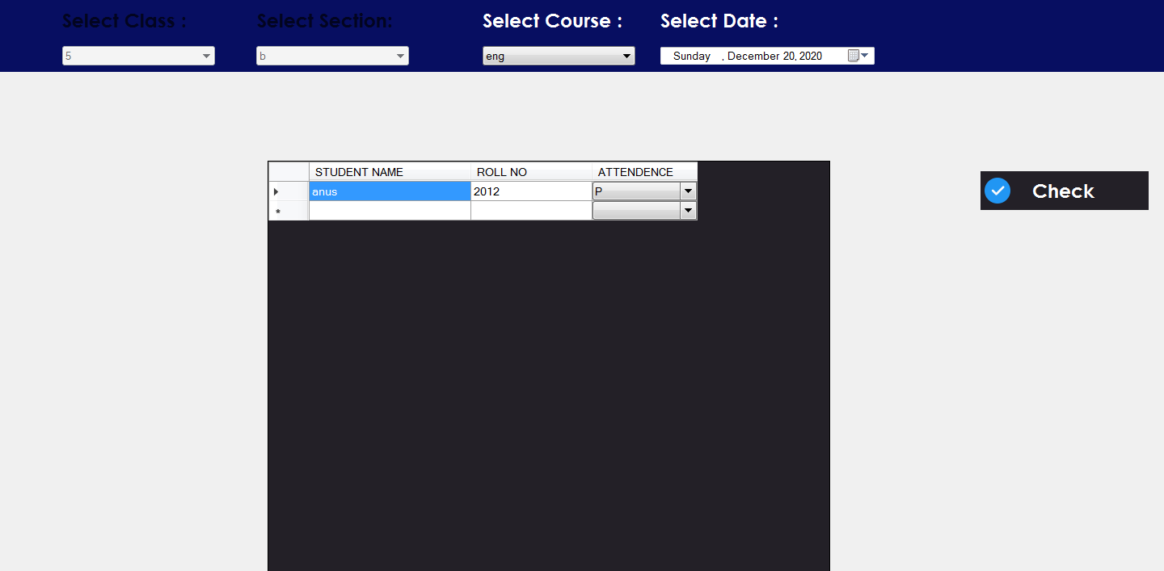

Substitutivity: In order to logout from system, the user can click on logout button or even the close button of page to logout the system. Similarly, to return the homepage, user can click on the back button.

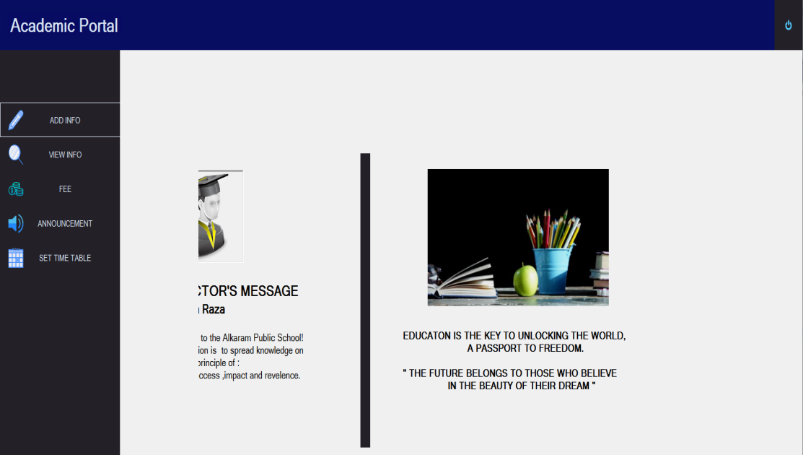

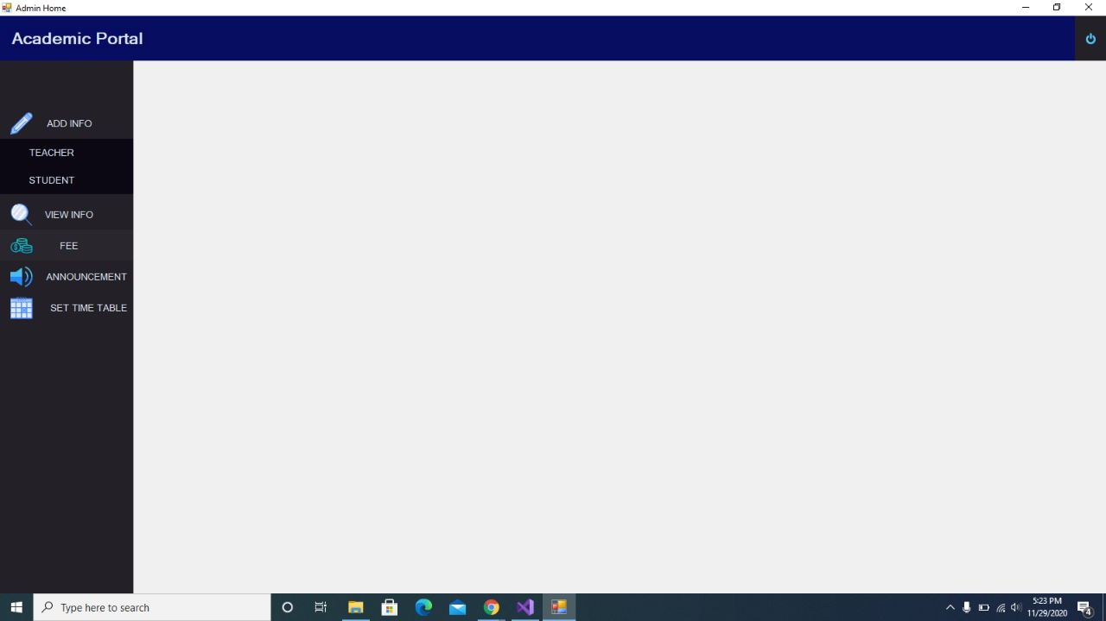

Observability: The user can perceive the state of the system with the help of operation visibility as mentioned above. Also, persistence can be form in User (student) page of fee when its submission dateline is over and a fee is not paid then a notification red color will appear on the button.



Persistence

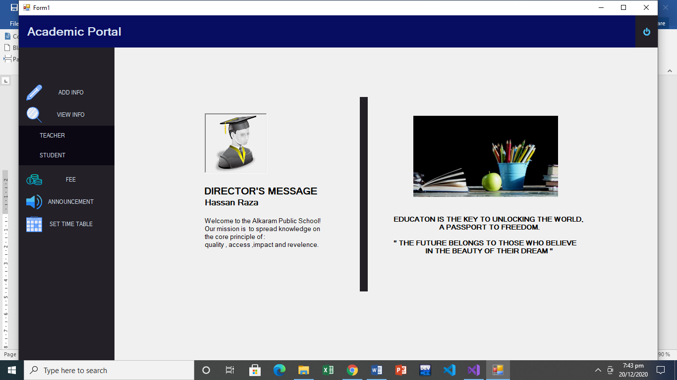Responsiveness: The pages loading time will be same throughout the running of the system. Also, the menu driven approach is also used.

Task Conformance: The all services will be provided to the user to achieve its goal, for example to view the student from its cnic number, or class wise.

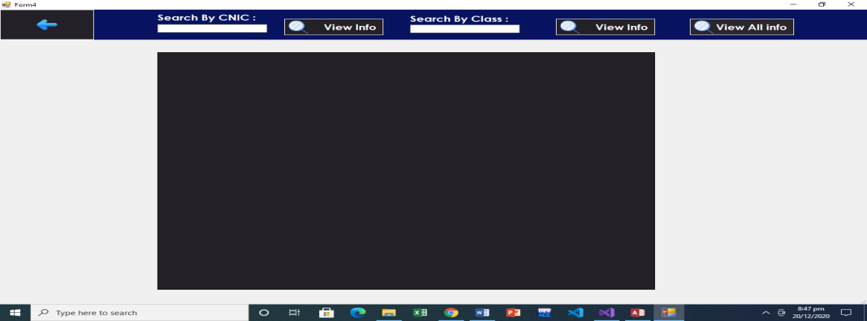

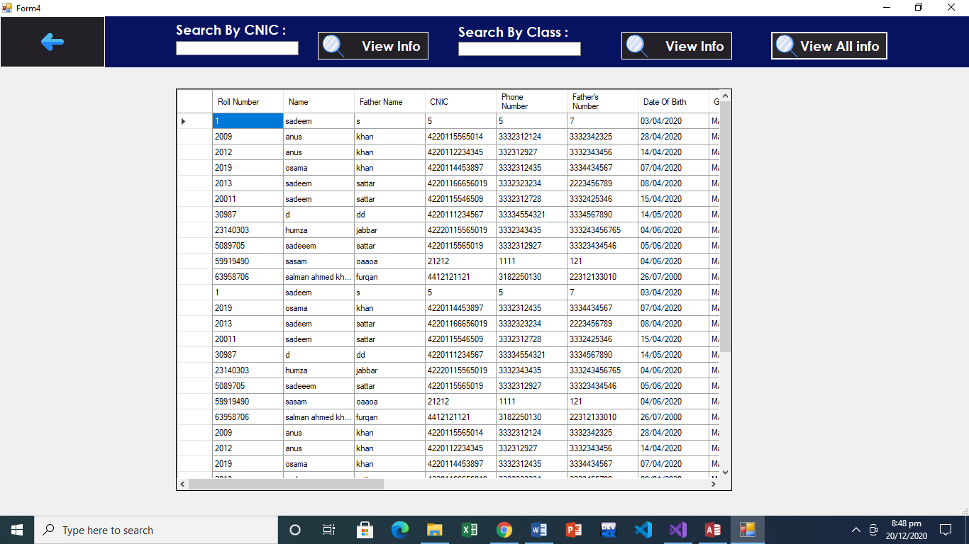

Recoverability: The exceptions will be provided if the user does some error through which the user can view the error and recover it.

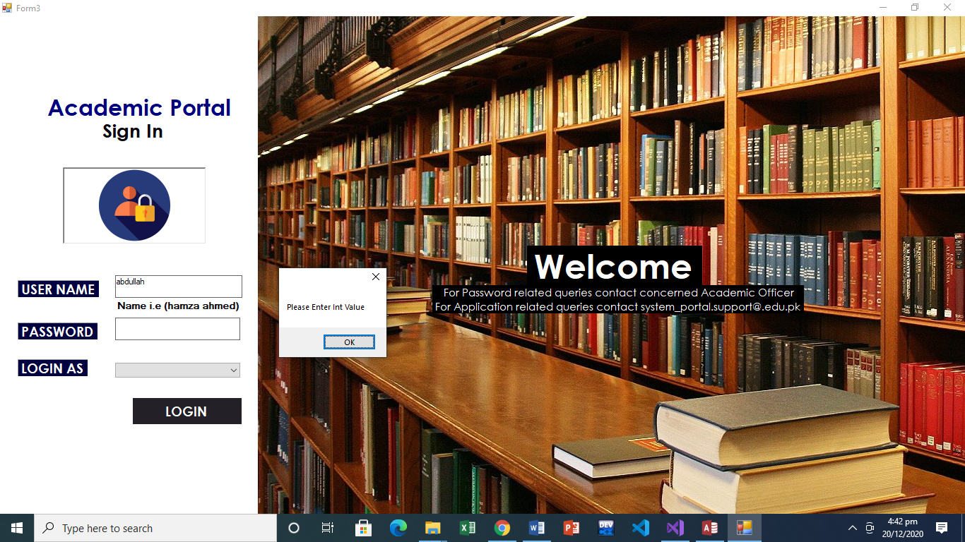

**Usability Metrics**

Effective: The system shall provide all the functionality to user (admin, teacher & student) as per their requirement and fulfill their goal.

Efficiency: The time taken to achieve the required goal.

Satisfaction: The rating scale of user satisfaction.

|  |  |  |  |
| --- | --- | --- | --- |
| Rules | Effective | Efficiency | Satisfaction |
| Learnability | Percentage of functions learned. This is done by using metaphors, operation visibility and consistence | Time to learn the system. | The ease of use and learning |
| Error tolerance | Simple error handling by providing system error dialog box | Time spent on correcting error will be a second due to the provided system error dialog box | The error handled successfully |
| Task Conformance | Support for the user tasks and completeness by providing immediate feedback of its task | As soon the task is done, its completeness feedback will be provided immediately | The task if user completed successfully |
| Flexibility | The user(admin) can perform same task for example view teacher by his cnic or designation in order to achieve his goal | As soon the user will click on the view button, the data will be presented to user within a second. | The completion of the task of user. |